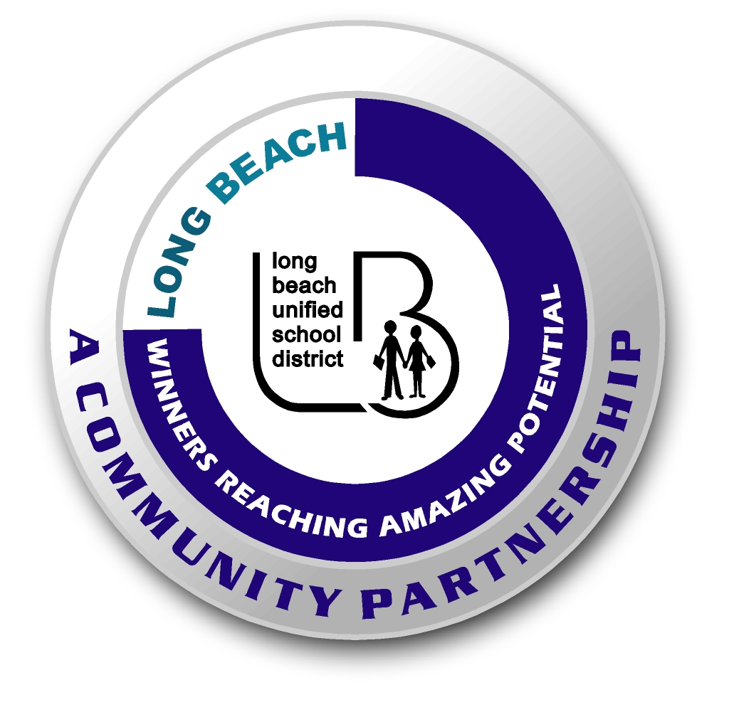
Long Beach WRAP

Lesson Title or Topic: Science in the Kitchen

Program Leader: _____________________________ Date: __________

Grade Level: 6-8th School Site: __________________________

Materials Needed: (List)
- half -pint of whipping cream or heavy cream, 2-cup plastic jar with a watertight lid, whisk fork, crackers, and butter knife

Preparation Time: 20 min Lesson time: Varies

Content Standard(s) Structure Matter

What will be learned from this activity? (Objective)
- Students will learn how butter is made.
- Students will understand the simplistic elements of chemistry in our everyday life.

Steps of the lesson: (Scientific Method of Investigation)

Introduction: (Questions/Hypothesis):
- Science is all around us, especially in the kitchen. “…fish don’t fry in the kitchen and beans don’t burn on the grill”. Why? We bake, fry, boil and steam ingredients. Simply known as chemistry.

Instruction:
- Pass out plastic jars and whipping cream to students.

Activity: (Procedure)
- Have students pour whipping cream into the jar and tighten the lid so that it is sealed tight.
- Have students shake the jar back and forth for about 20 minutes.
  - Put on dancing music to keep the shaking fun. (optional)
- Have students look in the jar from time to time.
  - If the contents start to get too thick to shake, use a whisk or fork to stir them more.
- When the contents start to form yellowish clumps, you are done.
  - The solid yellow particles you see are butter.
- Spread some of the butter onto a cracker and taste it.

Closure: (Conclusions/Results)
- What happened when you shook the cream for several minutes?
  - It causes clumps of fat in the cream with the protein to form solid butter.
- What is the liquid left behind?
  - It is called buttermilk.
- What happens to the cream in the milk?
  - The cream rises to the top (creating skim milk, low-fat milk and whole milk).

