
Long Beach WRAP

Lesson Title or Topic: Ecology and Me (Filling)

Program Leader: _____________________________ Date: __________

Grade Level: 6-8th School Site: __________________________

Materials Needed: (List)
- Assembled Ecocolumn
- Bottle Biology Kit (see Bottle Biology Handout Attachment)
- Soil (dirt), water, plants, compost, local insects (spiders, snails, etc)

Preparation Time: 10 min Lesson time: Day 3 (3 of 3 lessons)

Content Standard(s) Ecology

What will be learned from this activity? (Objective)
- Students will understand the concept of ecosystems.
- Students will understand the importance and role of an ecosystem friendly environment.
- Students will understand how an ecosystem is developed.
  - climate
  - natural habitation

Steps of the lesson: (Scientific Method of Investigation)

Introduction: (Questions/Hypothesis):
- Does air moving fast have more pressure than slow air?

Instruction/Activity:
Precipitation:
- Punch two or three small holes in section D in order to “water” our Ecocolumn.
Air Holes:
- Make plenty of tiny air holes in section G
Aquariums and tree-hole ponds:
- Make section F watertight by applying silicone to the connecting parts.
  - the aquarium will be greatly affected by any water dripping in from the units above
  - The pond can drain through small holes poked in the cap.
Decomposing matter and soil:
- Fill sections C and E with the soil or compost matter
  - Make sure a porthole is cut in the side
  - Cover the hole with a piece from another bottle
  - Make a hinge with a wide piece of tape
  - Poke holes in the cap at the bottom of the decomposition so that water can drain
Habitations:
- Create a habitat for the insects that were collected in the scavenger hunt.
- Fill the section A/B with soil, plants and s twig or two in order to give the predators a good home.

Closure: (Conclusions/Results)
- Student Observation:
  - Record in notebook the changes in the Ecocolumn.
  - How does the soil affect your plant habitat?
  - Explain how one predator successfully survives opposed to the other.

Bottle Biology Handout Attachment

Tool Box
These tools will enable you to construct any of the investigation columns on this site. Some of these items are not critical – you do not need to use a razor to start bottle cuts, for example, or a tapered reamer to enlarge holes – but they can make construction easier.
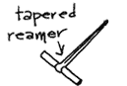 | 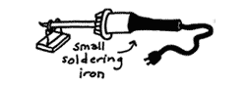 | 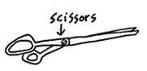
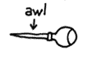 | 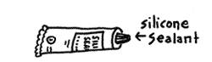 | 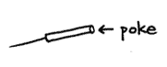
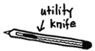 | 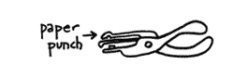 | 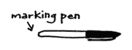
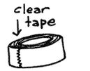 | 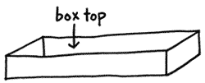 | 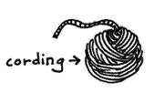
- Box top or drawer to stabilize bottle while making cutting lines
- Marker, wax pencil or crayon for drawing cutting lines
- Cutting blade or utility knife to start cut
- Scissors to cut bottle
- "Poke," darning needle or diaper pin to make air holes
- Awl to make holes in bottle caps and film cans
- Tapered reamer for enlarging holes
- Paper punch for making large holes in thin plastic
- Clear waterproof postal or bookbinding tape to join columns
- Silicone sealant to waterproof joints
- Clothes line, polyester or nylon craft cording
- Small inexpensive electric soldering iron
- Hair dryer
- Plant Light House

